EXPERIMENTS (11-17)

EXP 11.Out of Boundary Paths
CODE:
def findPaths(m,n,N,i,j):
dp=[[0]*n for _ in range(m)]
dp[i][j]=1; count=0
for _ in range(N):
temp=[[0]*n for _ in range(m)]
for x in range(m):
for y in range(n):
if dp[x][y]:
for dx,dy in [(1,0),(-1,0),(0,1),(0,-1)]:
nx,ny=x+dx,y+dy
if 0<=nx<m and 0<=ny<n:
temp[nx][ny]+=dp[x][y]
else:
count+=dp[x][y]
dp=temp
return count
print(findPaths(2,2,2,0,0))
OUTPUT:
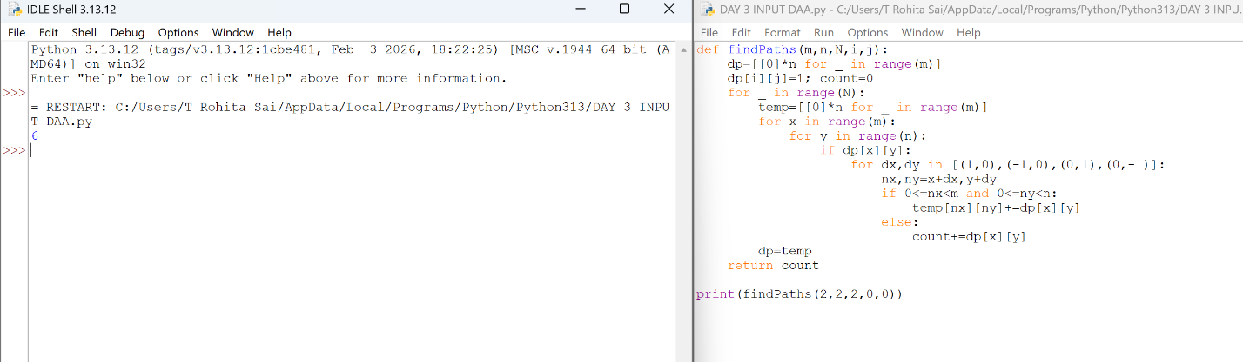

EXP 12.House Robber (Circular)
CODE:
def rob(nums):
def f(a):
p=c=0
for x in a: p,c=c,max(c,p+x)
return c
return max(nums[0],f(nums[1:]),f(nums[:-1]))
print(rob([2,3,2]))
OUTPUT:
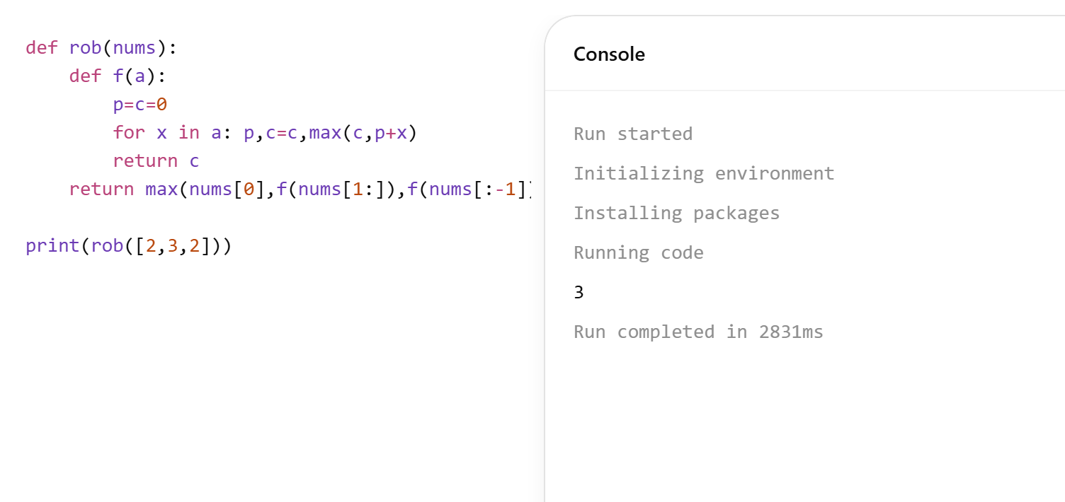

EXP 13.Climbing Stairs
CODE:
def climb(n):
a,b=1,1
for _ in range(n): a,b=b,a+b
return a
print(climb(4))
OUTPUT:
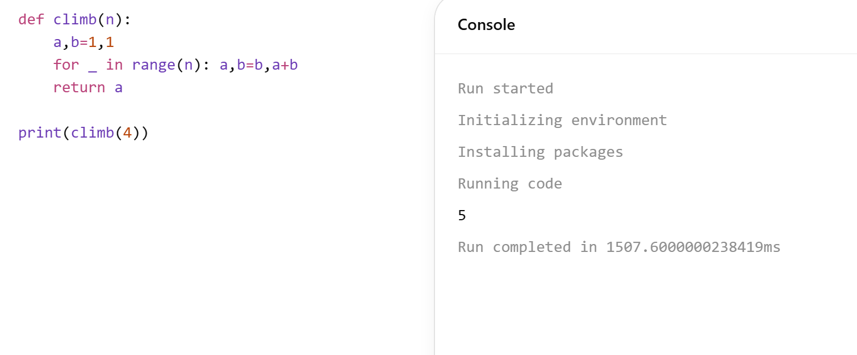

EXP 14. Unique Paths
CODE:
def uniquePaths(m,n):
dp=[1]*n
for _ in range(m-1):
for j in range(1,n):
dp[j]+=dp[j-1]
return dp[-1]
print(uniquePaths(3,7))
OUTPUT:
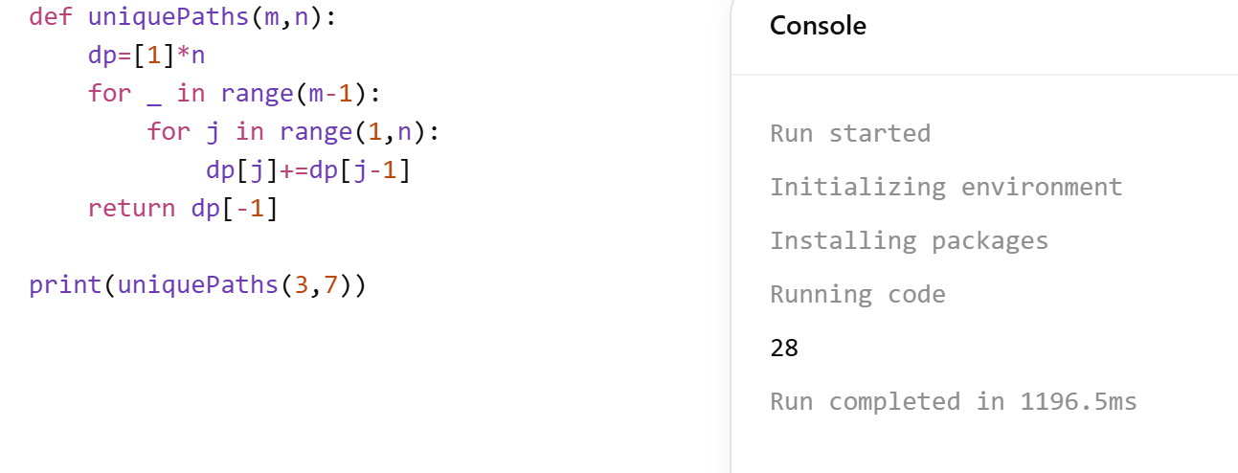

EXP 15. Large Group Positions
CODE:
def largeGroup(s):
res=[]; i=0
for j in range(len(s)):
if j==len(s)-1 or s[j]!=s[j+1]:
if j-i>=2: res.append([i,j])
i=j+1
return res
print(largeGroup("abbxxxxzzy"))
OUTPUT:
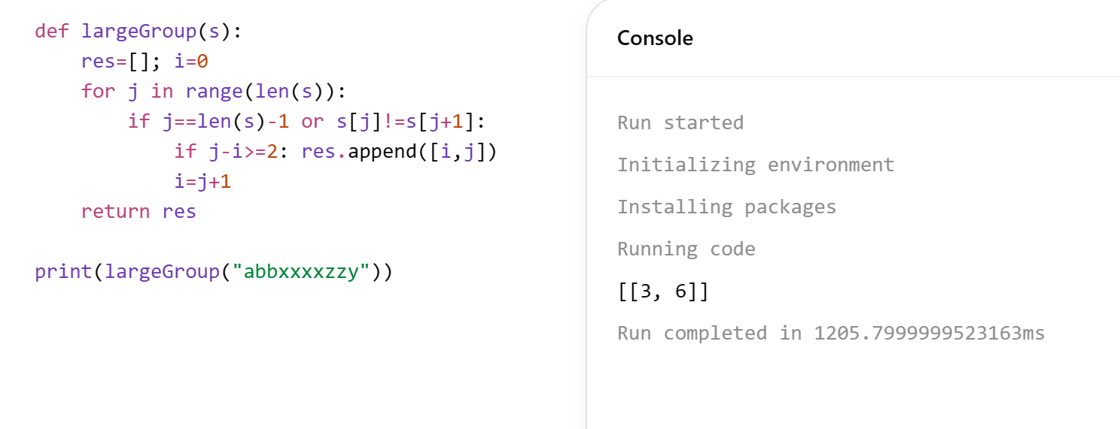

EXP 16. Game of Life
CODE:
def gameOfLife(b):
m,n=len(b),len(b[0])
for i in range(m):
for j in range(n):
live=sum(b[x][y]&1 for x in range(max(0,i-1),min(m,i+2))
for y in range(max(0,j-1),min(n,j+2))
if (x,y)!=(i,j))
if b[i][j]==1 and live in [2,3]: b[i][j]=3
if b[i][j]==0 and live==3: b[i][j]=2
for i in range(m):
for j in range(n): b[i][j]>>=1
return b
print(gameOfLife([[0,1,0],[0,0,1],[1,1,1],[0,0,0]]))
OUTPUT:
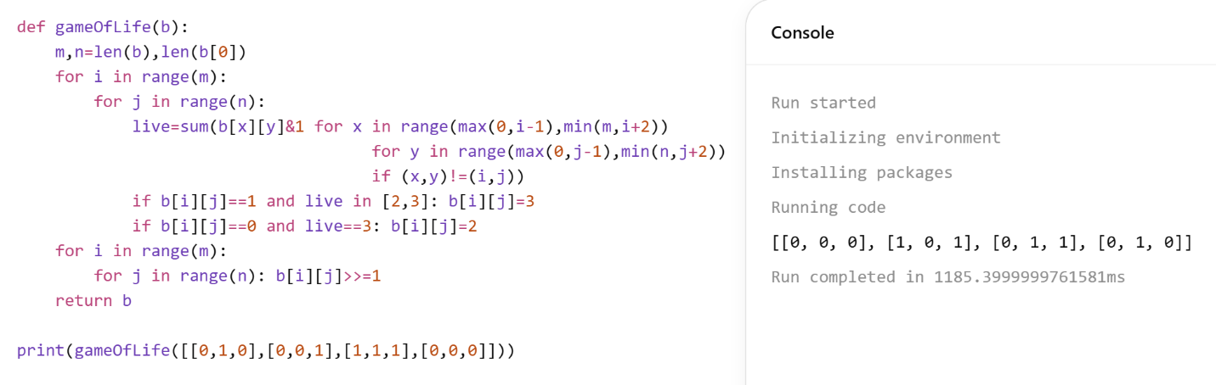

EXP 17. Champagne Tower
CODE:
def champagne(p,row,glass):
dp=[[0]*101 for _ in range(101)]
dp[0][0]=p
for i in range(row+1):
for j in range(i+1):
x=(dp[i][j]-1)/2
if x>0:
dp[i+1][j]+=x
dp[i+1][j+1]+=x
return min(1,dp[row][glass])
print(champagne(2,1,1))
OUTPUT:
